This document is an update to the arduino setup 07.doc document. I’ve copied all the sections from Randy’s document that are still correct into this doc. For this version I used Arduino 0022 and Bourbon 2.30a loaded onto Windows 7.

**Useful links:**

CNTL+click to go there

Home roasters thread about this project

<http://homeroasters.org/php/forum/viewthread.php?thread_id=1774&rowstart=0>

Arduino SW

<http://arduino.cc/en/Main/Software>

Arduino roasting SW / Download page

<http://code.google.com/p/tc4-shield/downloads/list>

PWB info here

<http://code.google.com/p/tc4-shield/>

Schematic page

<http://www.mlgp-llc.com/arduino/public/tc4-controller-0106-sch.pdf>

Bill’s project page

<http://code.google.com/p/tc4-shield/>

Parts list, from Bill

<http://code.google.com/p/tc4-shield/wiki/BuildIt>

Quickstart page

<http://code.google.com/p/tc4-shield/wiki/QuickStartGuide>

Bill’s webpage

<http://bvwelch.com/>

# Install the Arduino sw

<http://arduino.cc/en/Main/Software>

Once on the page in the Arduino 0022 section, click on “windows” (if you have windows), and then “save as”. I used Arduino 0022 because of this post: <http://coffeegeek.com/forums/coffee/homeroast/561493#561493>

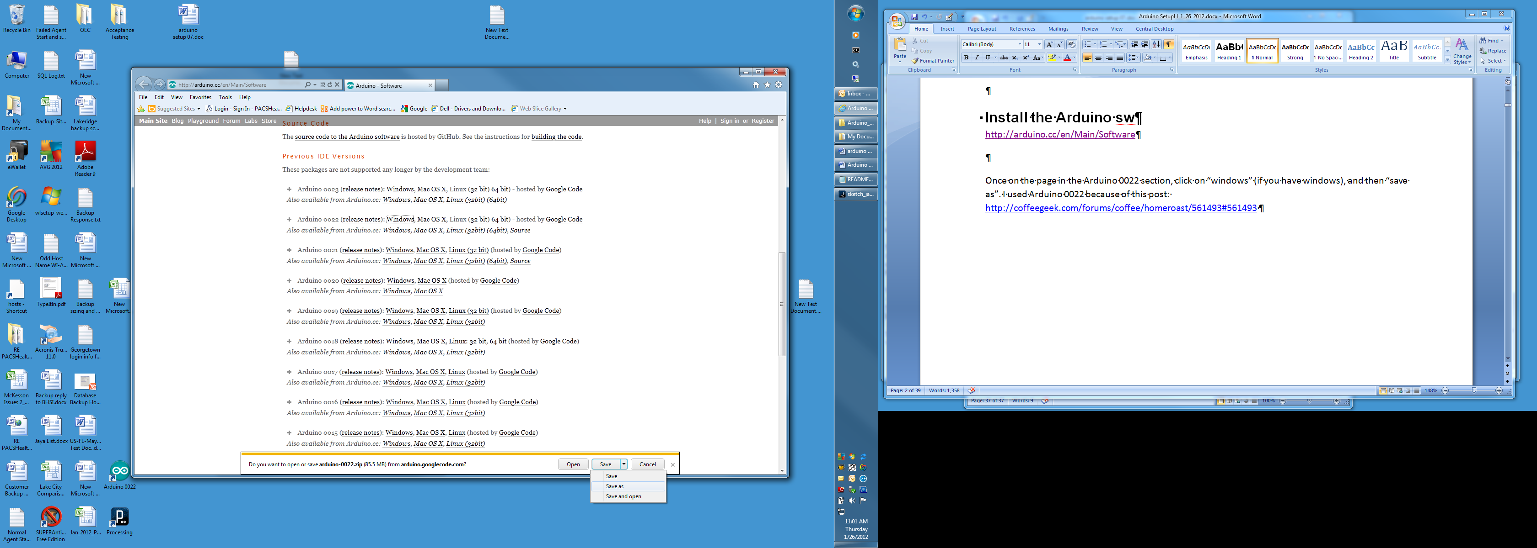

I saved to a folder I created, C:\Users\PH\Documents\Arduino_Bourbon Downloads but you can put yours wherever it makes sense to you.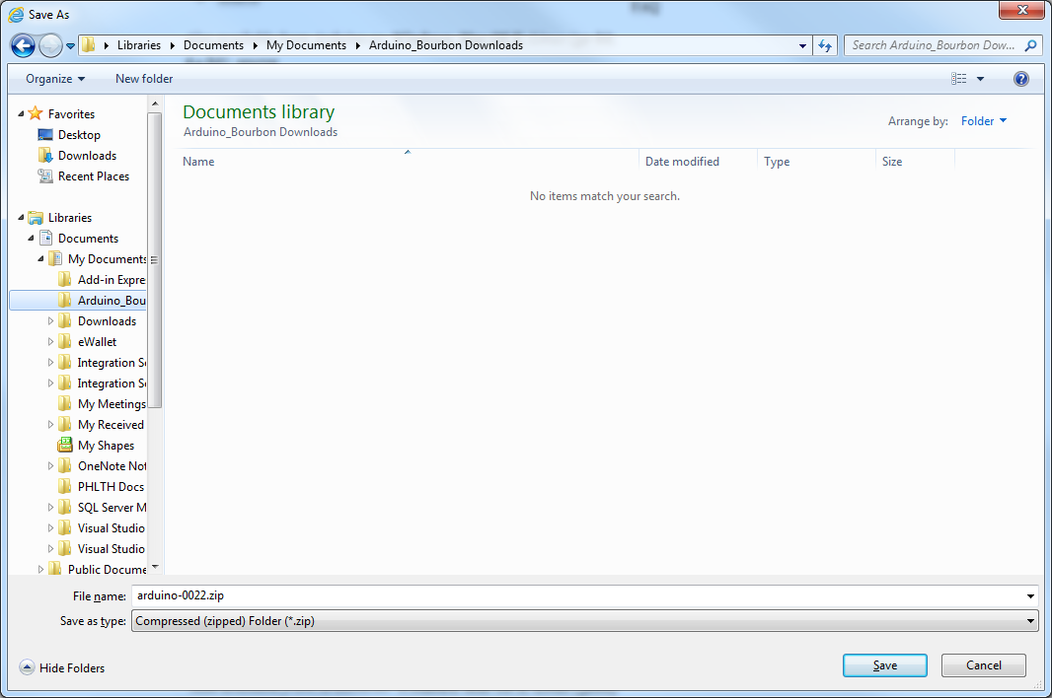

Click Save.

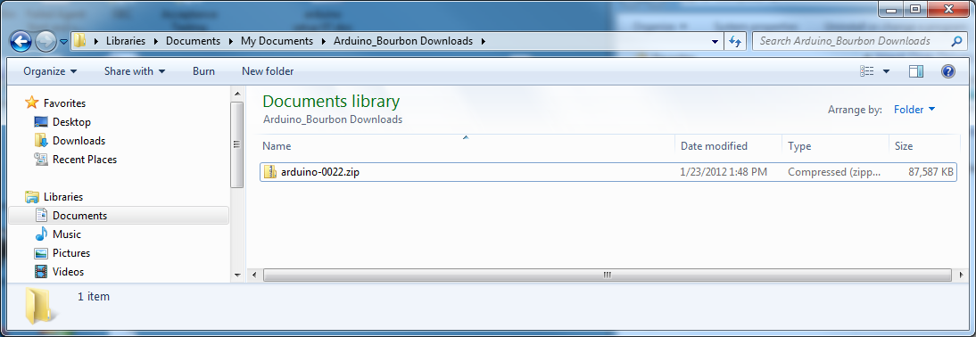

Right-click the zip file and click extract all.

Browse to C:\Program Files and click OK.

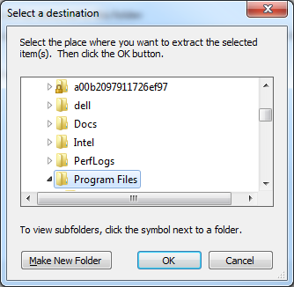

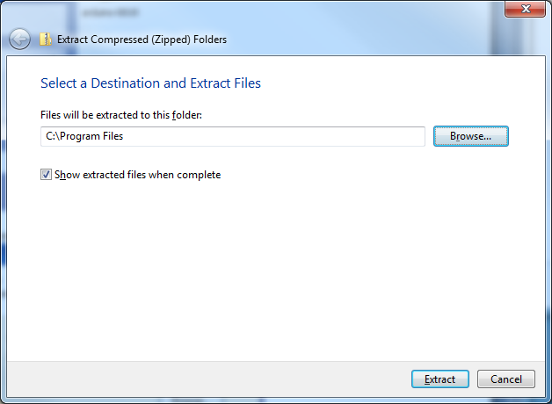

Click Extract. It takes a while to finish.

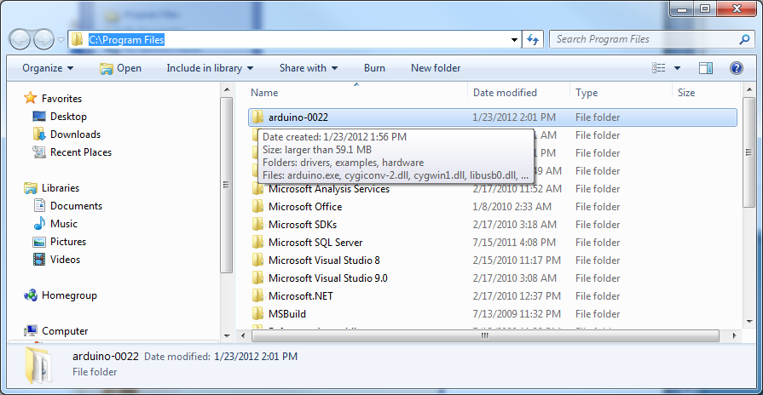

Files are now in C:\Program Files\arduino-0022. Select this directory. It should look like this:

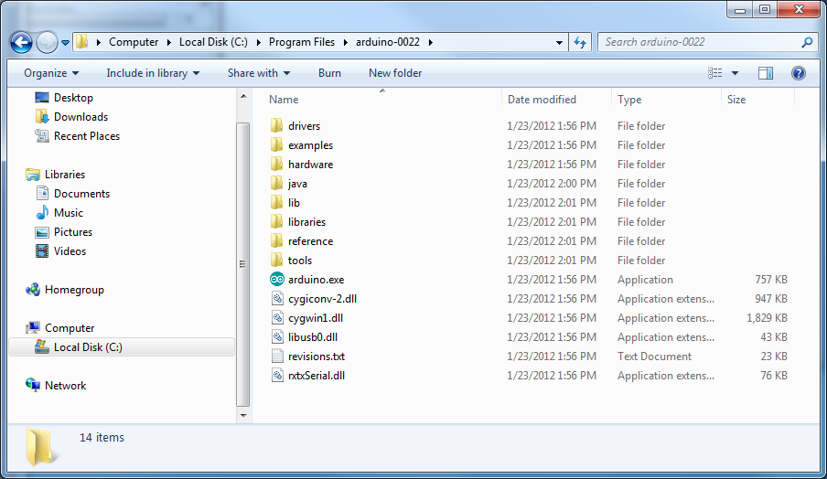

If you want, you can right click on the “arduino.exe” icon, and then create a shortcut. Then you can drag the shortcut to your desktop, to have a icon there to start arduino.

You can delete the “ardiuno-0018.zip” file now if you want.

# Install Processing Software

<http://processing.org/download/>

I initially installed Processing 1.5.1, but got rx-tx mismatches and intermittent Java errors. 1.2.1 seems to be much more stable.

Scroll down to Stable Releases and click on 1.2.1 Standard.

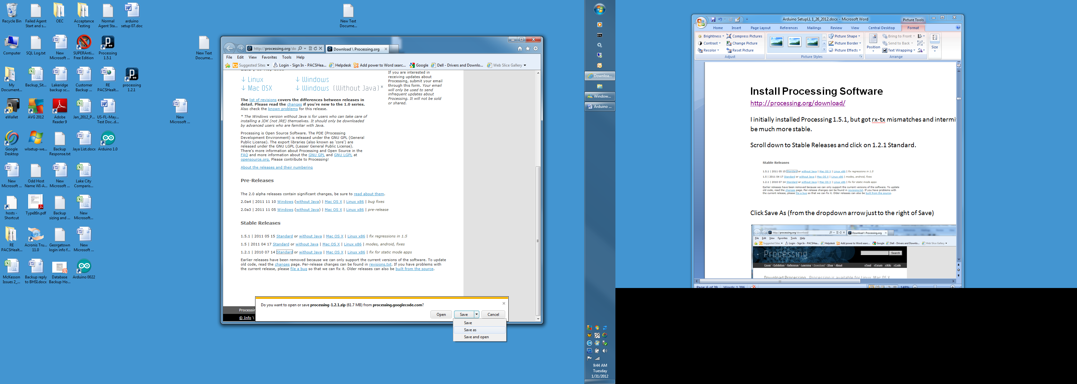

Click Save As (from the dropdown arrow just to the right of Save)



Click Save.

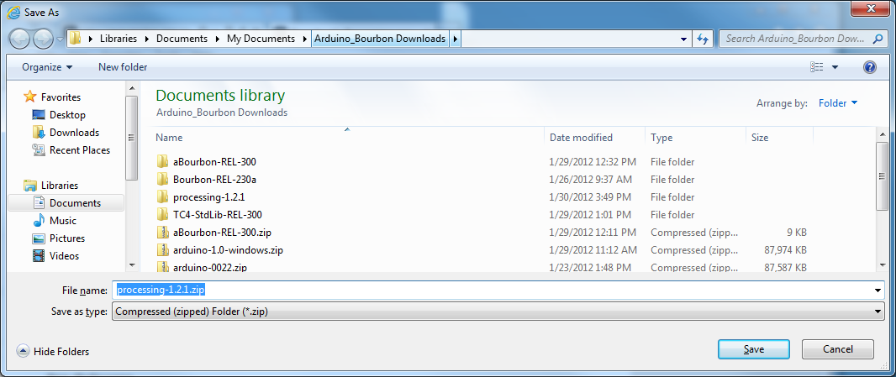

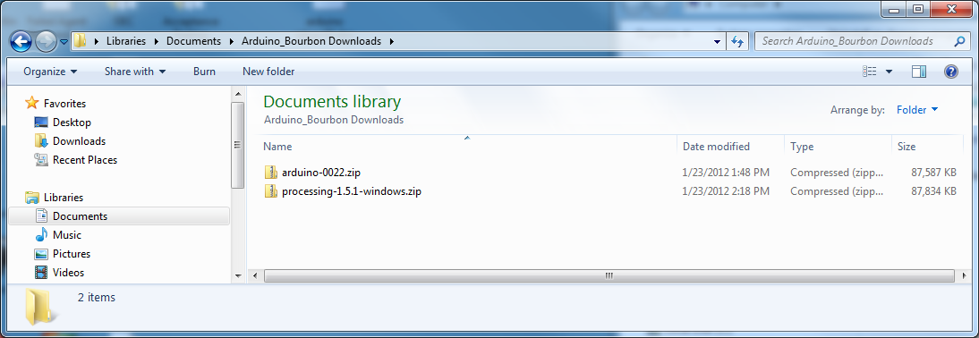

Extract to C:\Program Files\arduino-0022 by right clicking the zip file and clicking extract all.

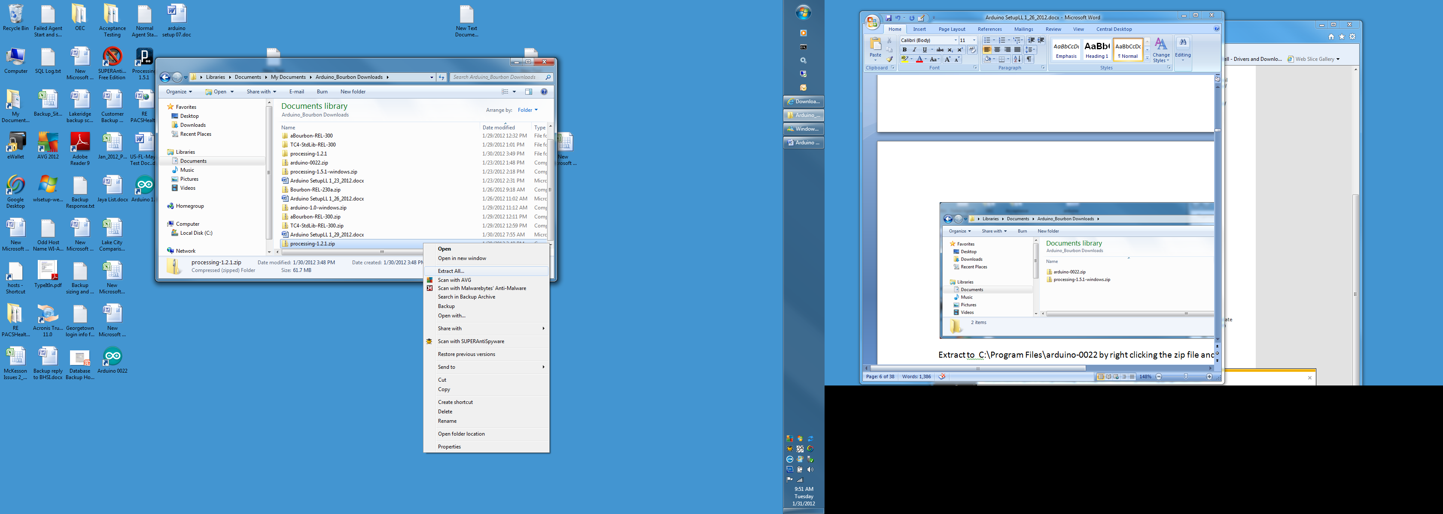

.

Browse to Arduino-0022 and click OK.

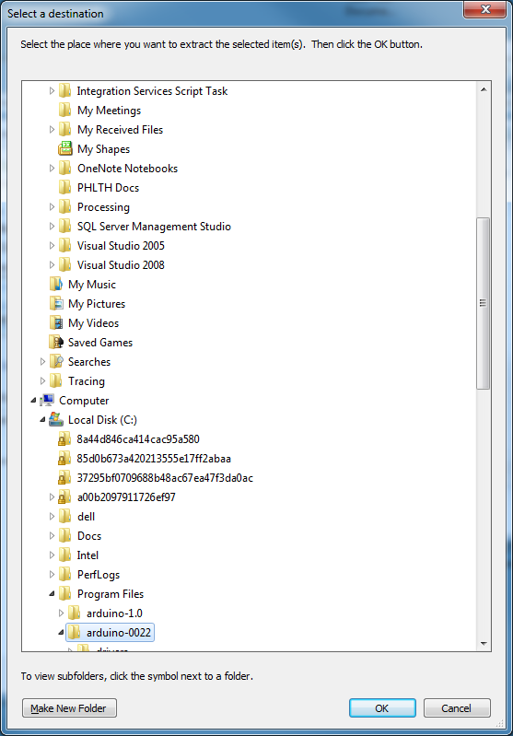

Click OK.

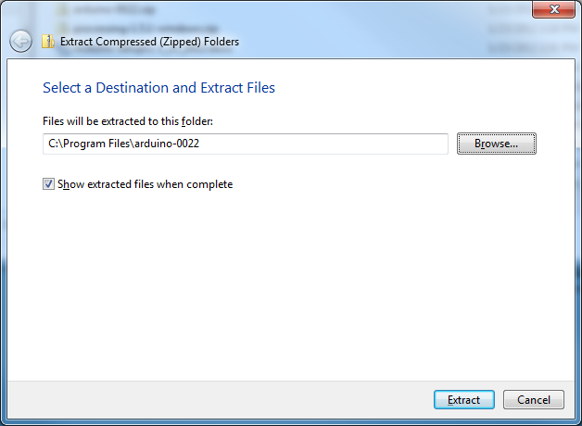

Click Extract.

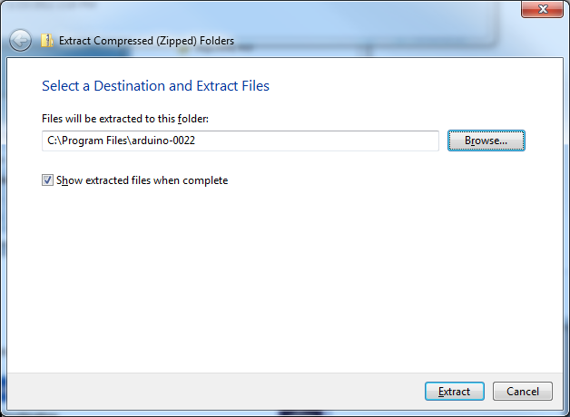

Navigate to the C:\Program Files\arduino-0022\processing-1.2.1 subdirectory. If you want you can right click on processing.exe, create a shortcut, and drag it to your desktop.

### 4 | Install the drivers

I’ve copied the sections through XP installation from Randy’s document. Windows 7 installation follows XP.

When you connect the board, Windows should initiate the driver installation process (if you haven't used the computer with an Arduino board before).

On Windows Vista, the driver should be automatically downloaded and installed. (Really, it works!)

On Windows XP, the Add New Hardware wizard will open:

* When asked **Can Windows connect to Windows Update to search for software?** select **No, not this time**. Click next.

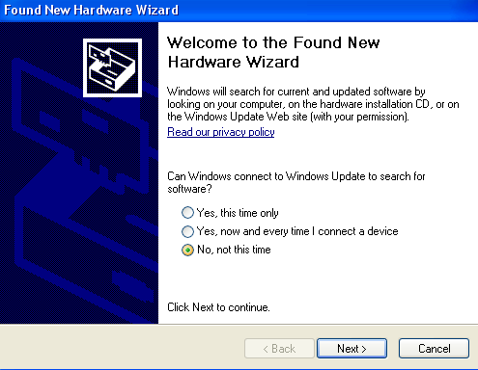

* Select **Install from a list or specified location (Advanced)** and click next.

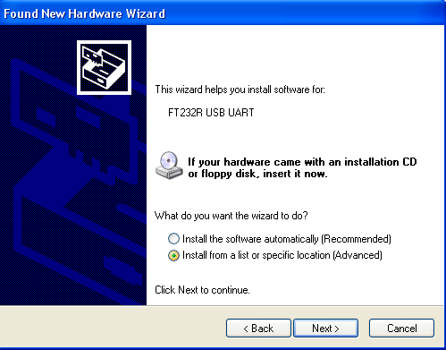

* Make sure that **Search for the best driver in these locations** is checked; uncheck **Search removable media**; check **Include this location in the search** and browse to the **C:\Program Files\arduino-0018\drivers\FTDI USB Drivers** directory of the Arduino distribution. (The latest version of the drivers can be found on the [FTDI website](http://www.ftdichip.com/Drivers/VCP.htm).) Click next.

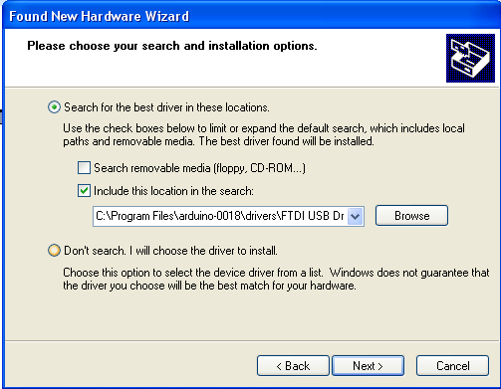

* The wizard will search for the driver and then tell you that a "USB Serial Converter" was found. Click finish.

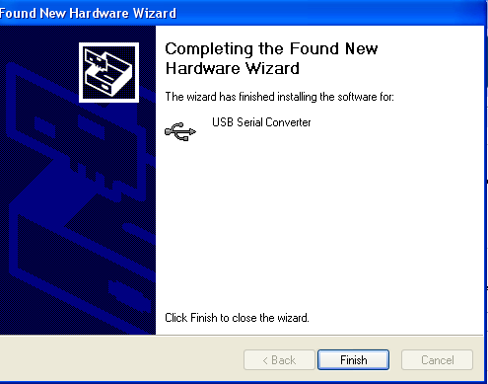

**Windows 7 installation:**

Connect the Arduino to the computer via USB. Windows will attempt to install drivers but will have errors.

Navigate to the device manager. One way to get there is to right click on computer…

. 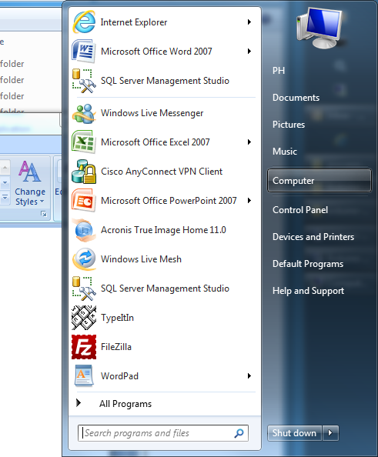

Click manage, which will open the Computer Management window. Click Device Manager. You should now see something like this.

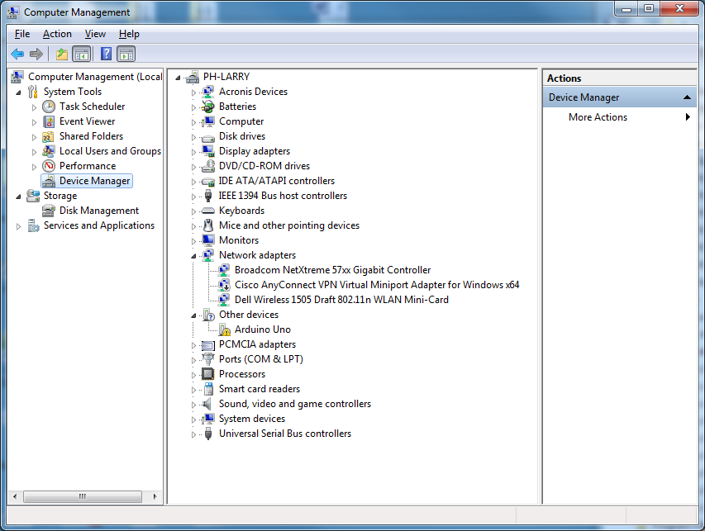

Note Arduino Uno with a yellow box with ! in it. Double click that line which will bring up the Arduino Uno Properties box.

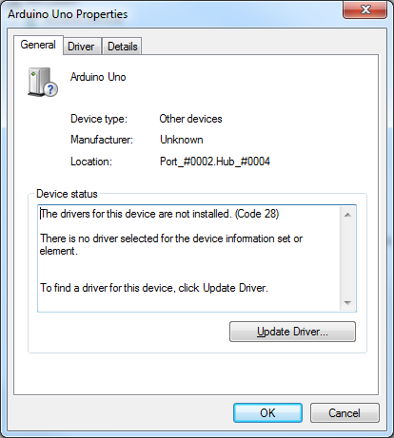

Click Update driver.

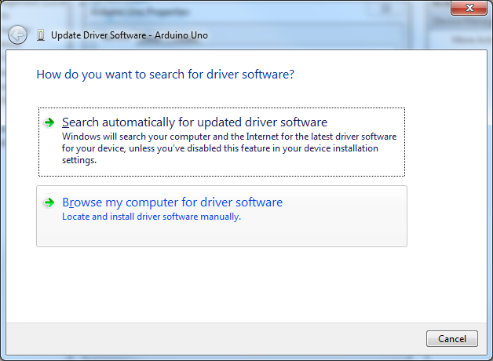

Click Browse my computer for driver software. Navigate to Drivers folder and click OK.

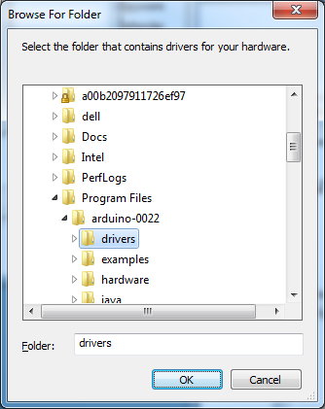

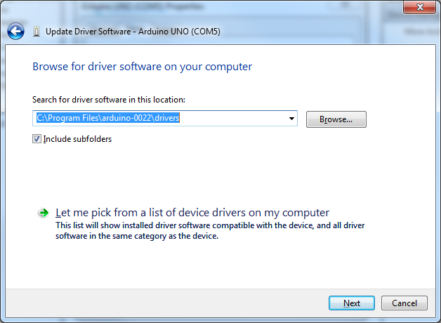

Click Next.

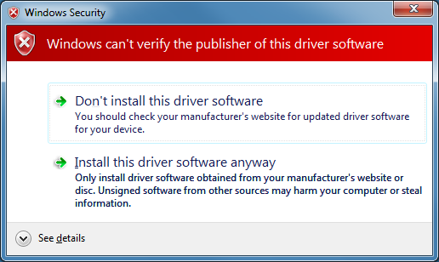

Click on Install this driver software anyway. After Windows has finished installing the driver you should see this window:

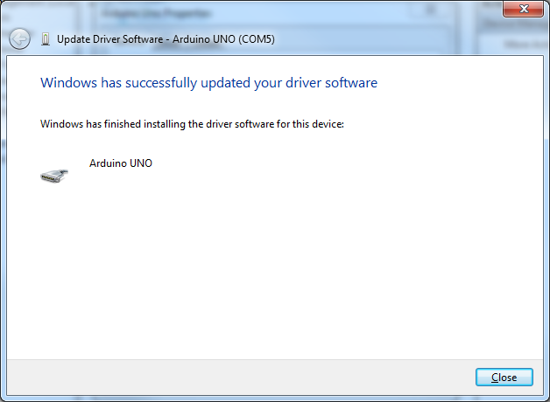

Note that the com port is listed at the top. In this case, it’s COM5.

The Arduino Uno Properties box should now show that the device is working properly.

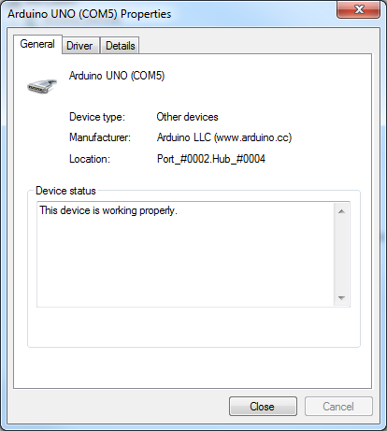

Arduino Uno is now listed under Ports (COM & LPT).

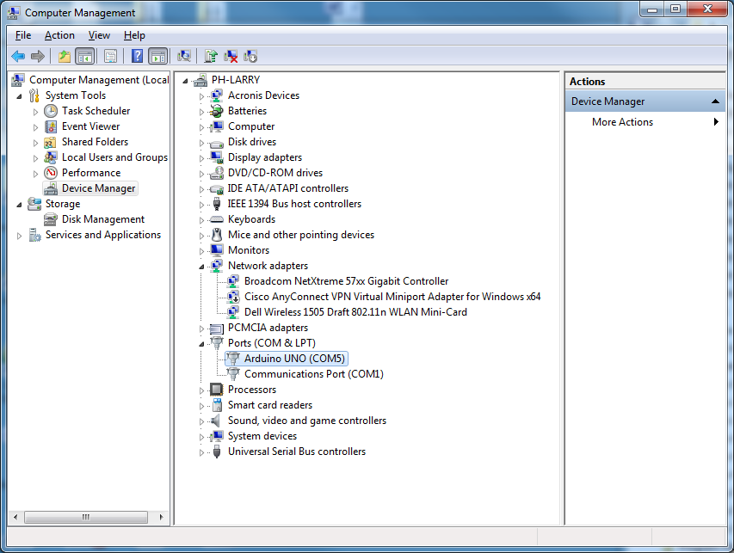

**5. Launch the Arduino application.**

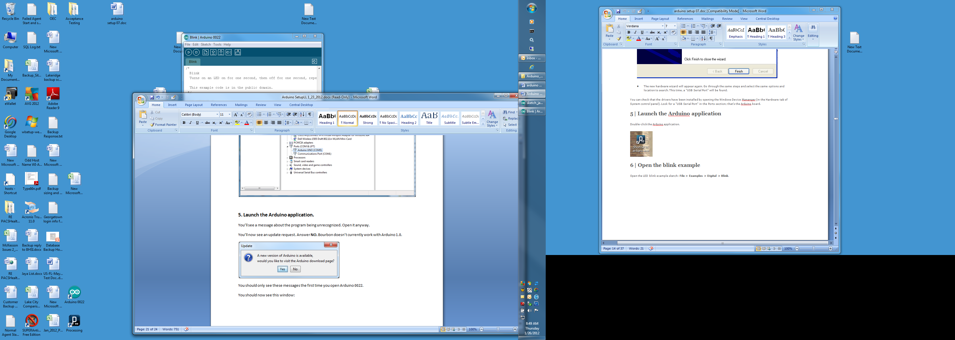

You’ll see a message about the program being unrecognized. Open it anyway.

You’ll now see an update request. Answer **NO.** Bourbon 2.3 doesn’t work with Arduino 1.0.

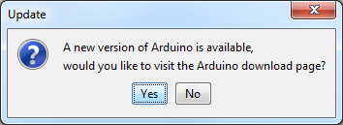

You should now see this window:

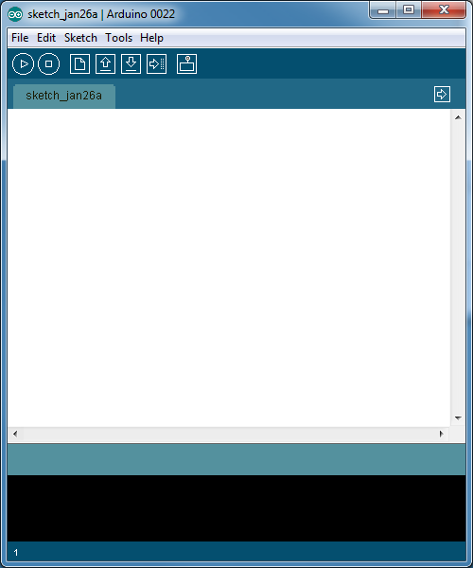

Select your board. (Tools> Board> Arduinoxxx) for whatever board you have. In my case it’s the Uno.

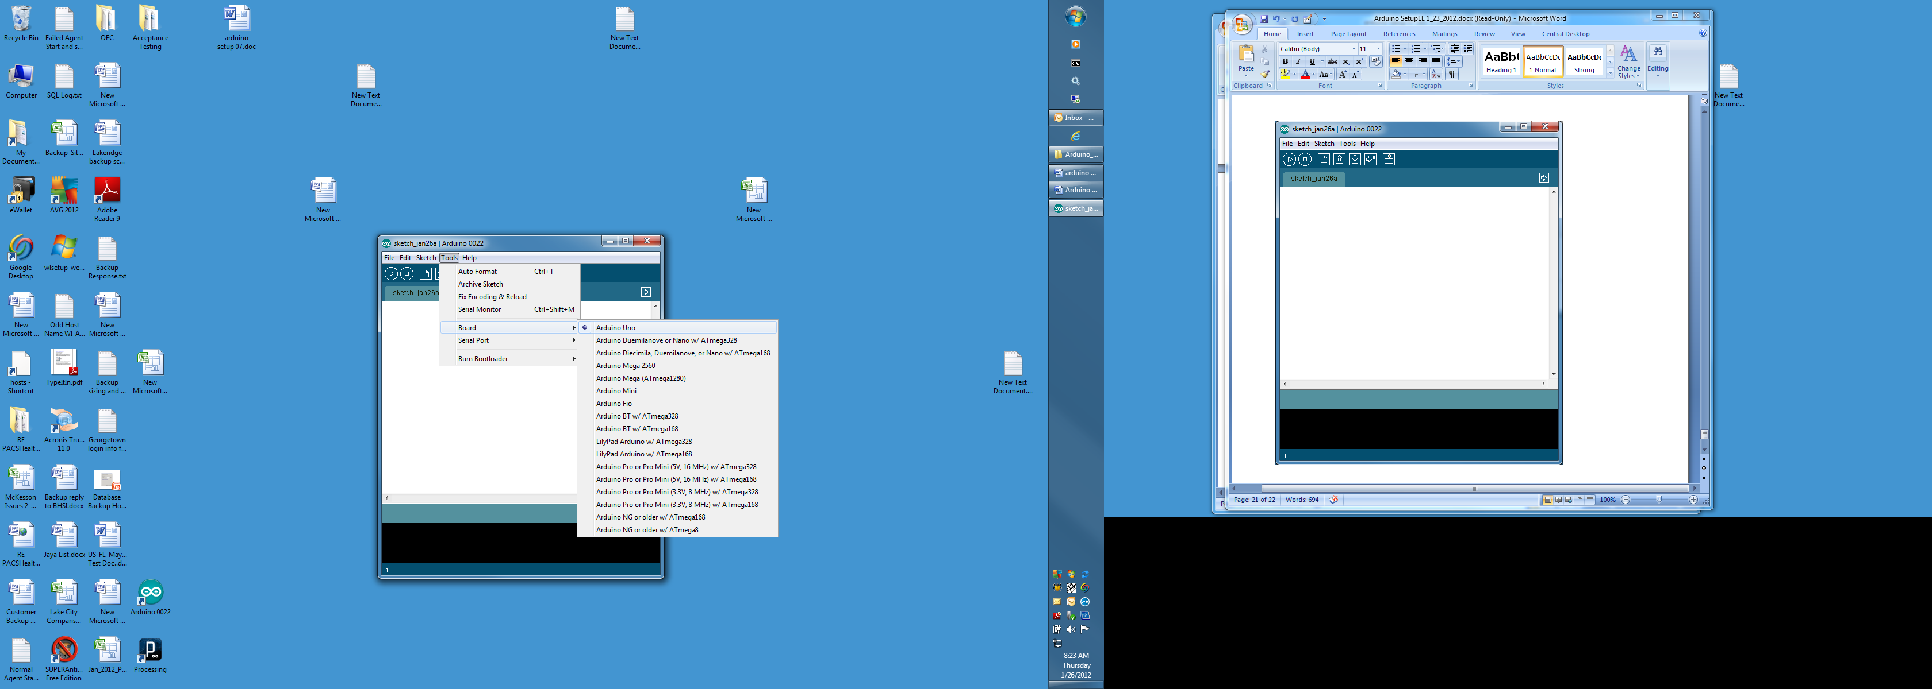

Select the serial port. In my case it’s COM5.

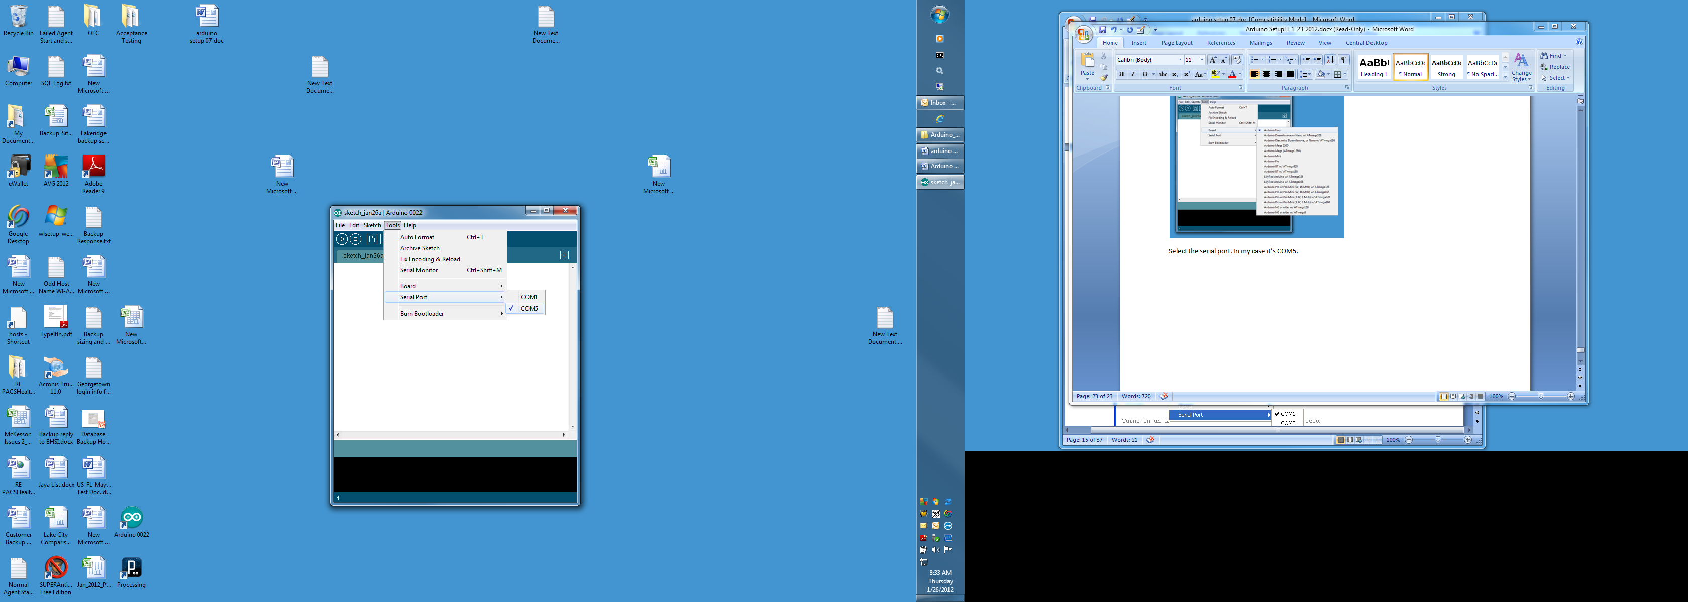

If you don’t know which serial port is the Arduino, disconnect it and see which port disappears.

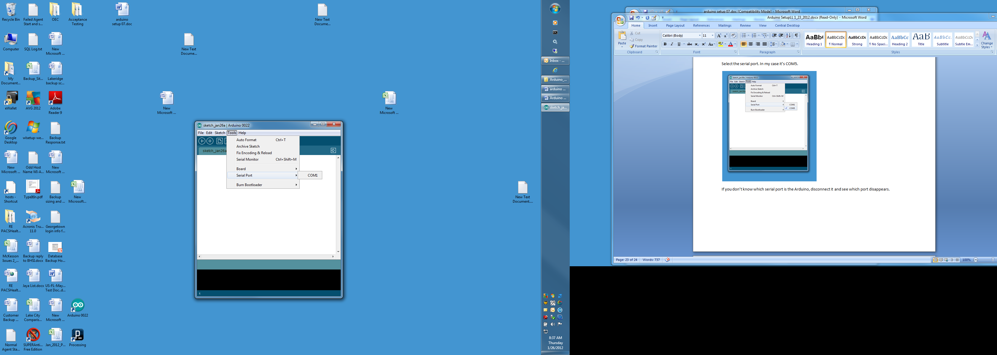

COM5 disappeared, so that’s the Arduino. Now reconnect the Arduino.

Open the Blink Example.

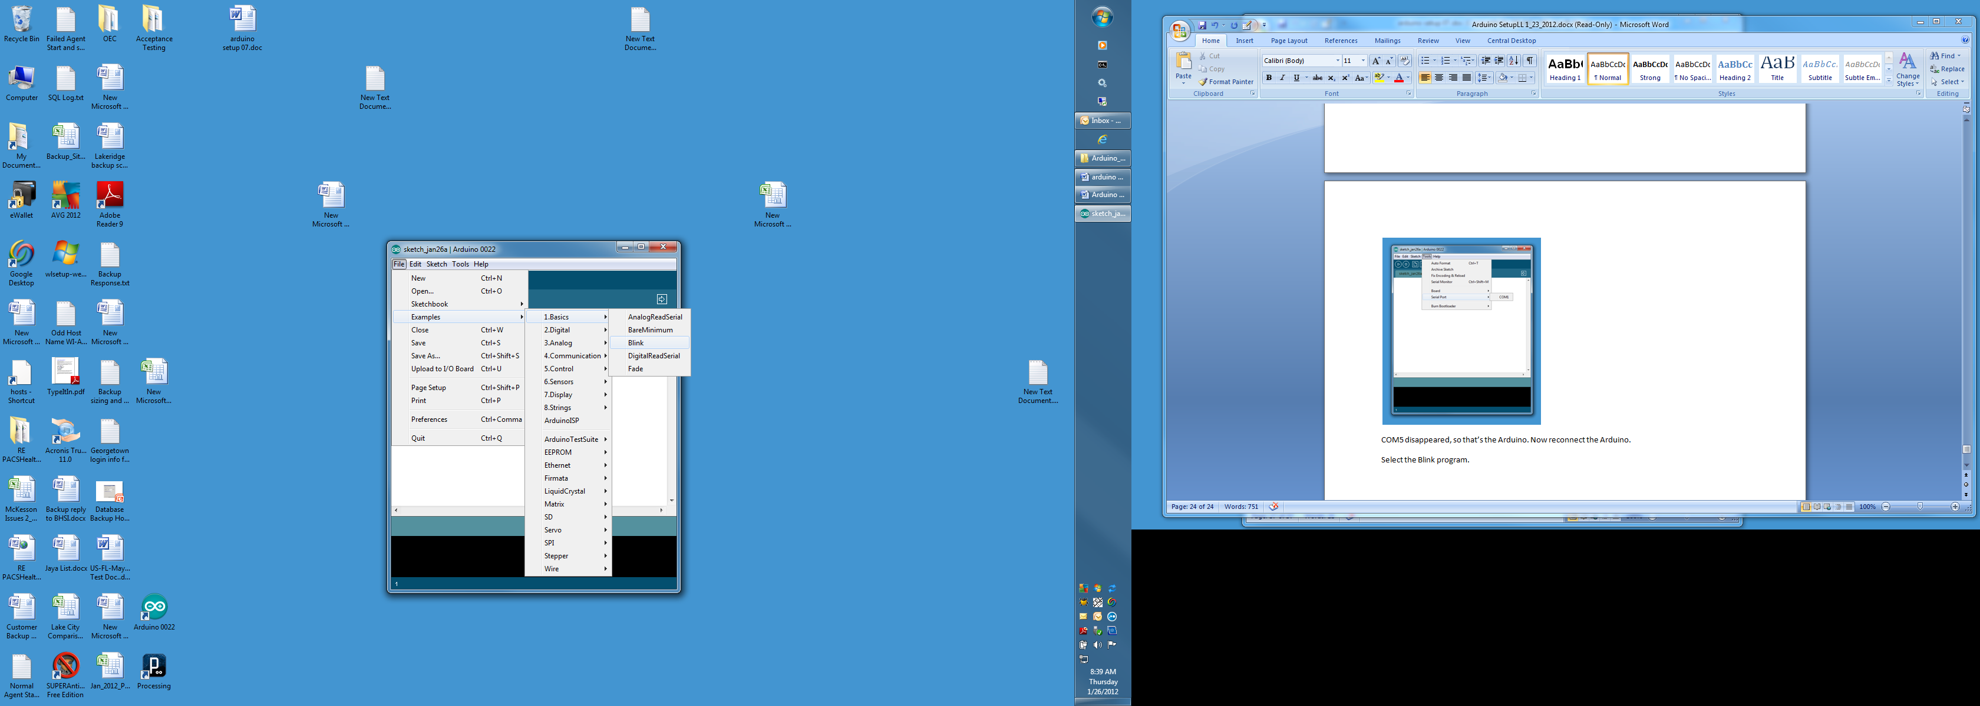

Upload the program to the board.

Now, simply click the "Upload" button in the environment. Wait a few seconds - you should see the RX and TX leds on the board flashing. If the upload is successful, the message "Done uploading." will appear in the status bar. (Note: If you have an Arduino Mini, NG, or other board, you'll need to physically present the reset button on the board immediately before pressing the upload button.)



A few seconds after the upload finishes, you should see the pin 13 (L) LED on the board start to blink (in orange). If it does, congratulations! You've gotten Arduino up-and-running.

If you have problems, please see the [troubleshooting suggestions](http://arduino.cc/en/Guide/Troubleshooting).

You might also want to look at:

* the [examples](http://arduino.cc/en/Tutorial/HomePage) for using various sensors and actuators
* the [reference](http://arduino.cc/en/Reference/HomePage) for the Arduino language

You can vary the blink rate by changing the delay parameters and re-uploading.

Don’t try to check out your LCD using the example programs that come with Arduino if you’re using the LCDapter. Wait until you have Bourbon loaded.

# Install the custom SW

Go here

<http://code.google.com/p/tc4-shield/downloads/list>

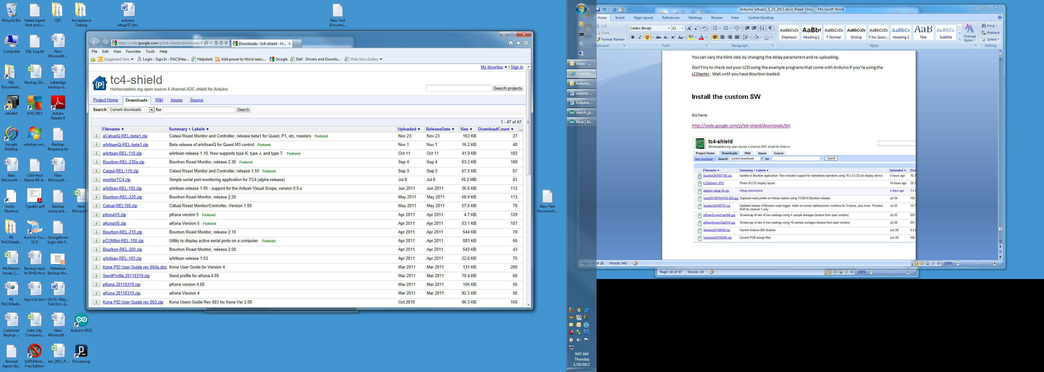

Click on the Bourbon-Rel-230a.zip which will bring up this window:

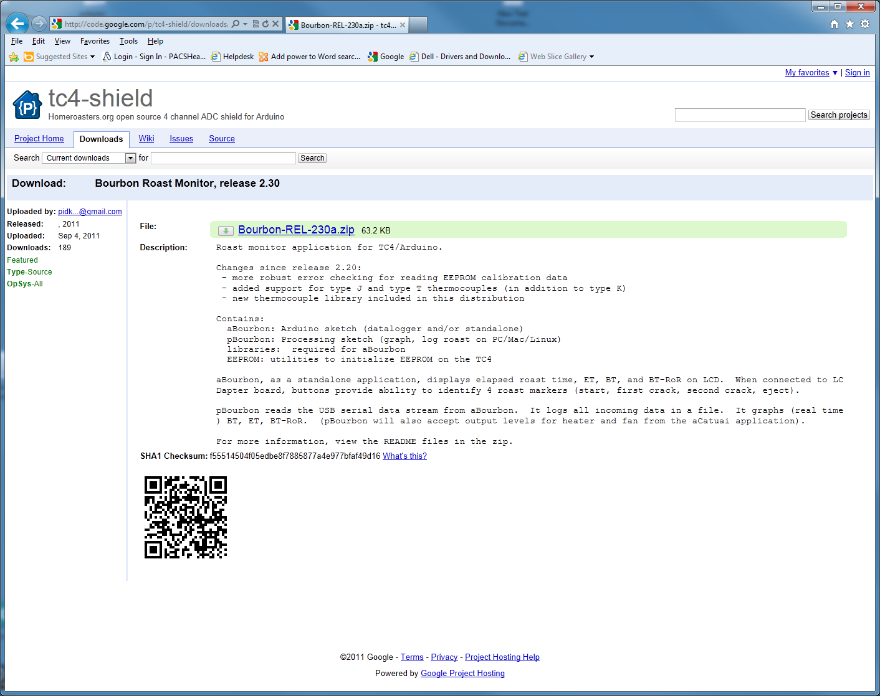

Click on the file name. Note the box at the bottom of the screen. Click on the down arrow next to Save. Click Save as.

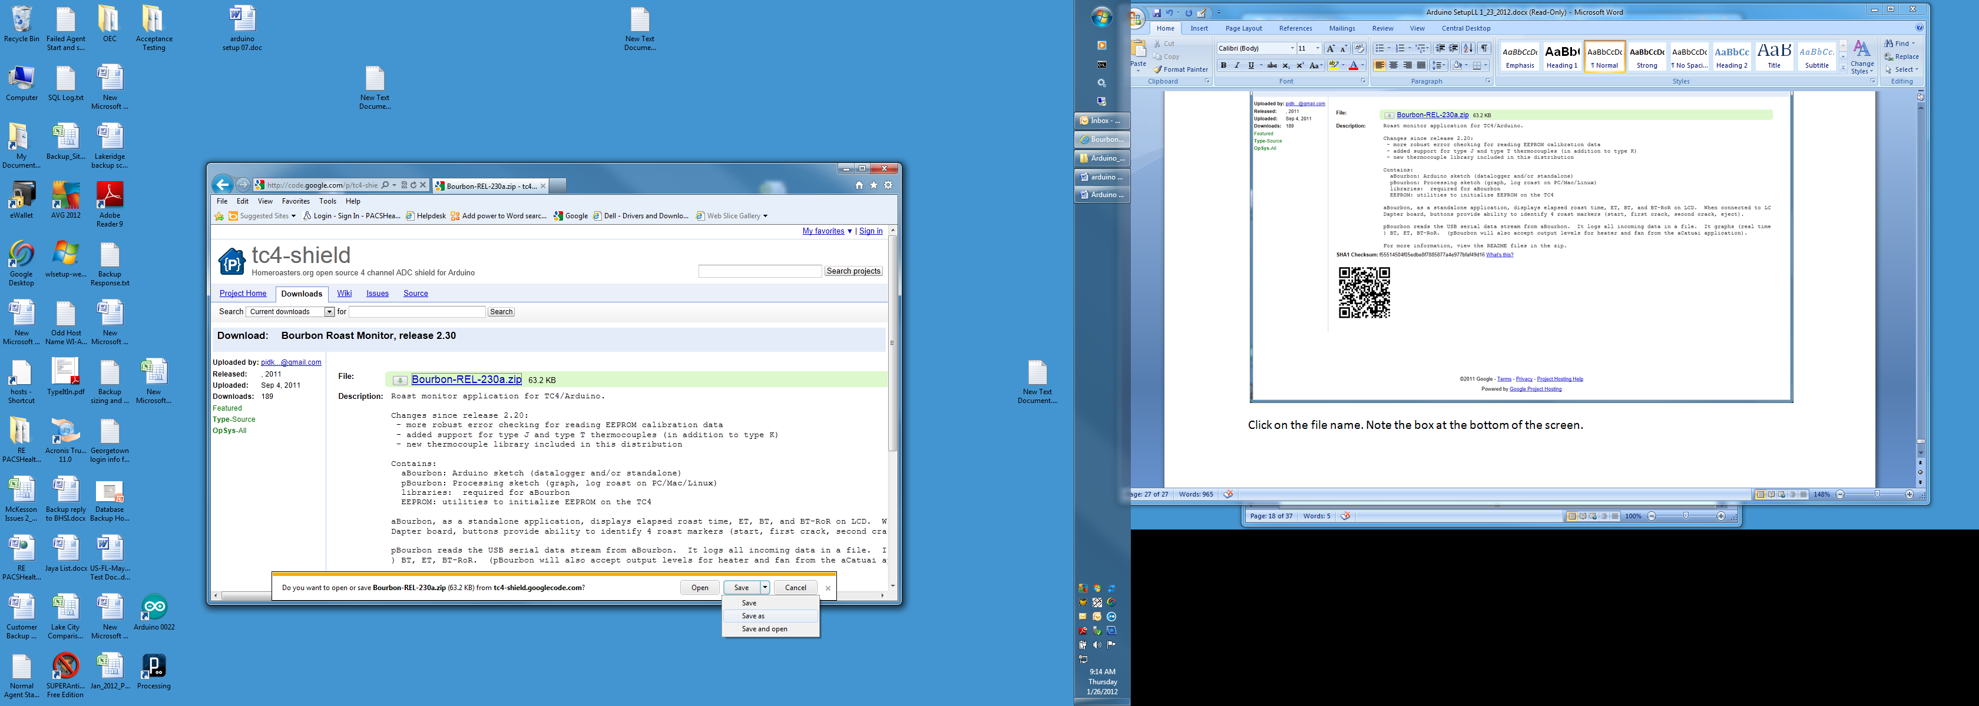

Navigate to wherever you saved your other Arduino zip files.

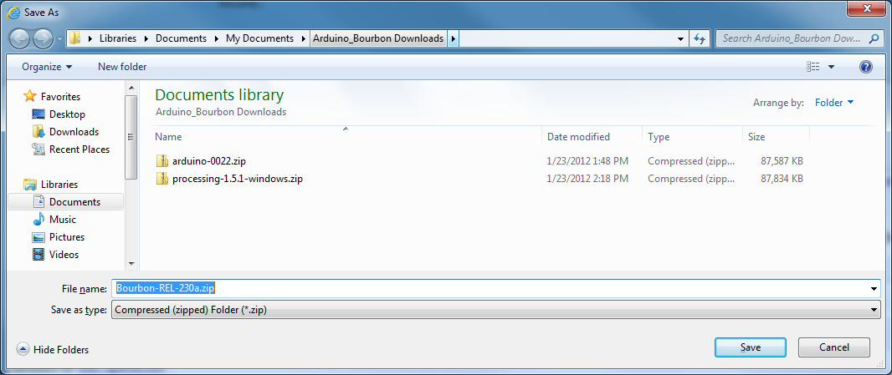

Click Save.

Open the zip file and click extract all files.

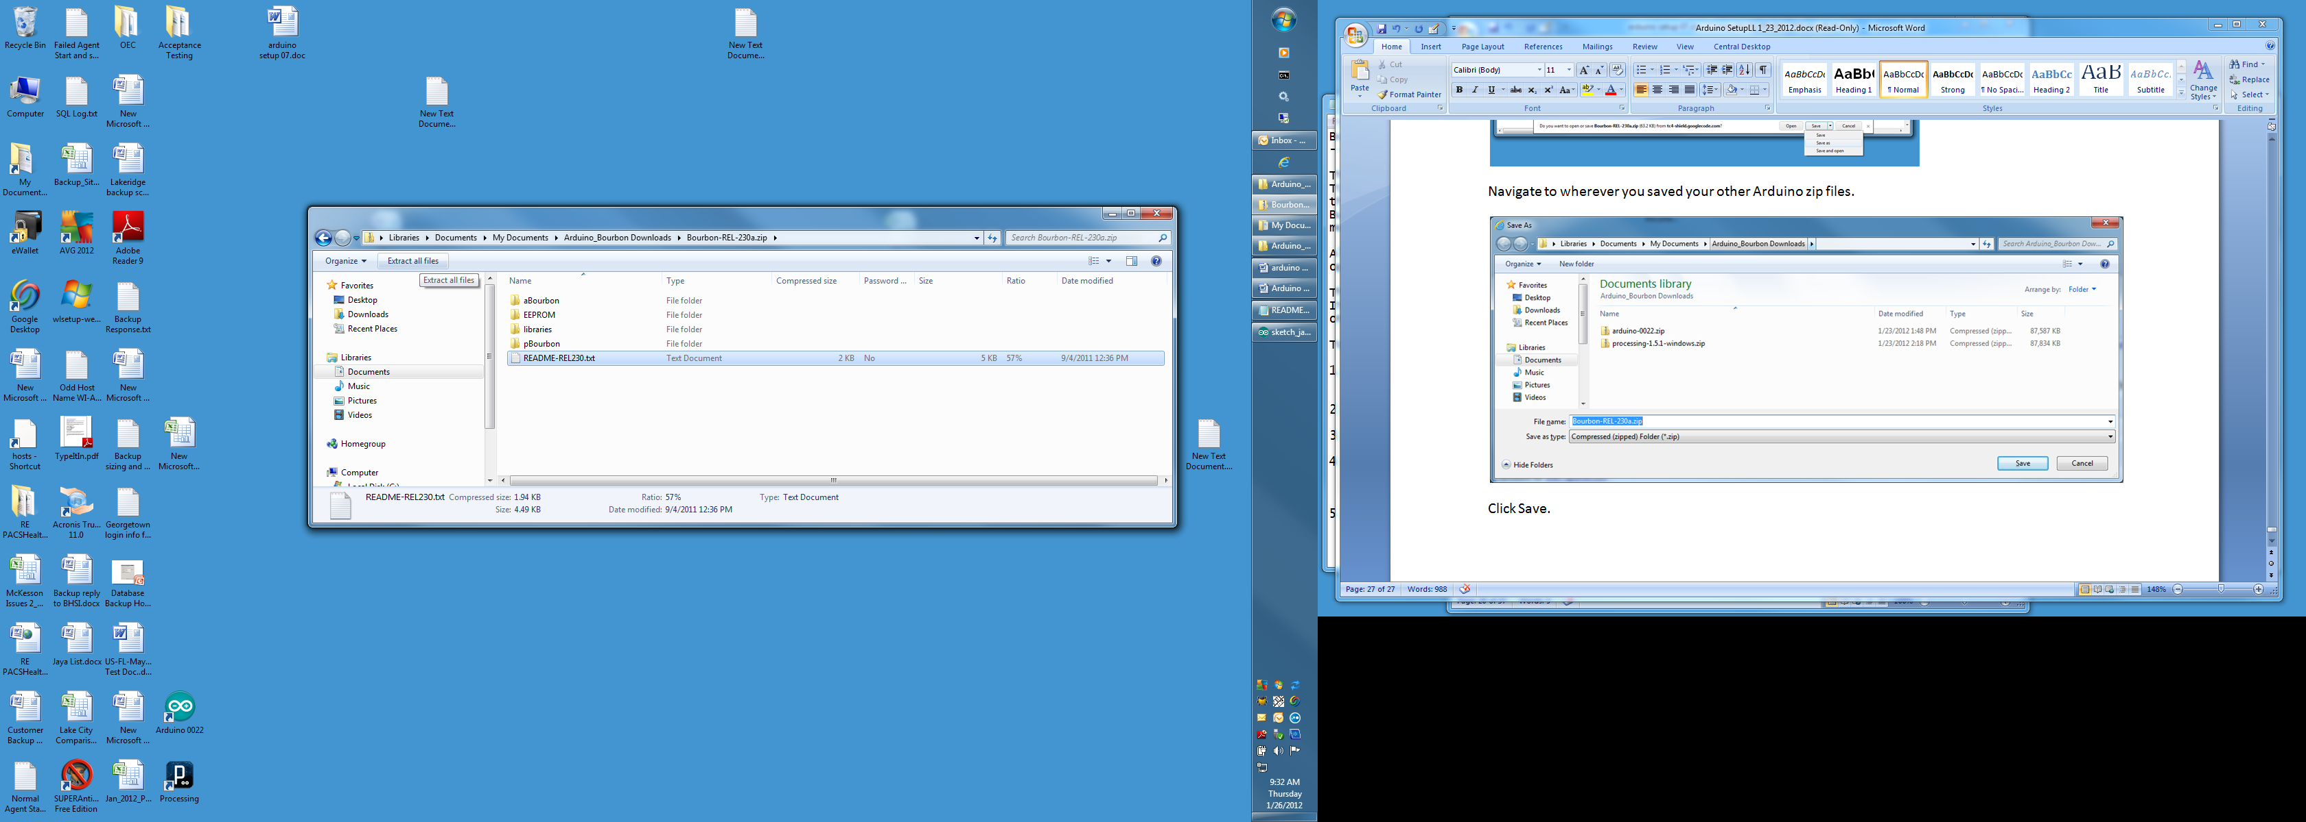

I kept the default location to extract to. We’ll be moving files from there to their final locations.

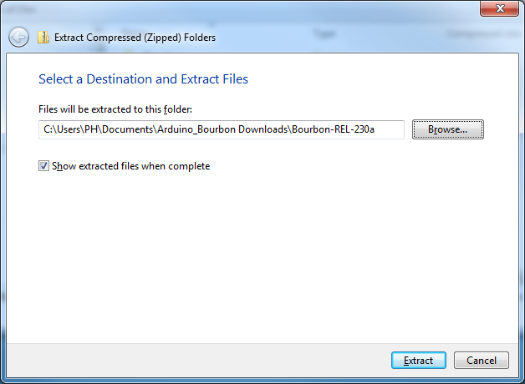

Copy the aBourbon file into the Arduino Sketchbook on your machine. You can find the Sketchbook location by opening Arduino and selecting File> Properties.

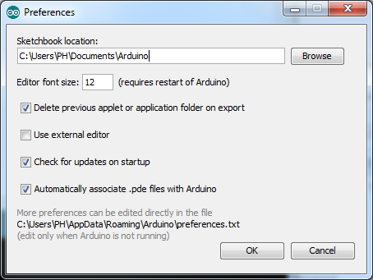

It should default to the My Documents\Arduino folder.

Copy the EEPROM file into the Arduino Sketchbook on your machine.

Copy the pBourbon Sketchbook into the Processing Sketchbook on your machine. You can find the location by opening Processing and selecting File> Preferences.

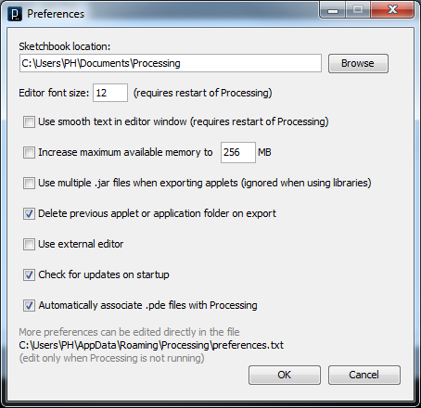

It should default to the My Documents\Processing Folder.

If you do not already have a "libraries" folder in your Arduino sketchbook, then copy the "libraries" folder from this distribution into your sketchbook. If you already have a "libraries" folder, then copy the individual library folders from this zip file into your sketchbook "libraries" folder.

Don’t forget to read the Readme File included with Bourbon.

The Arduino Subdirectory in My Documents should look like this:

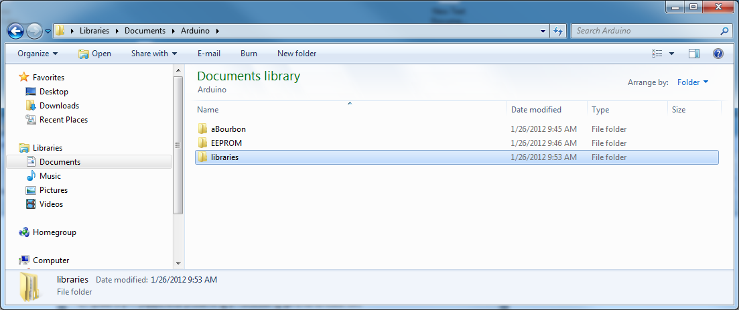

The Processing Subdirectory in My Documents should look like this:

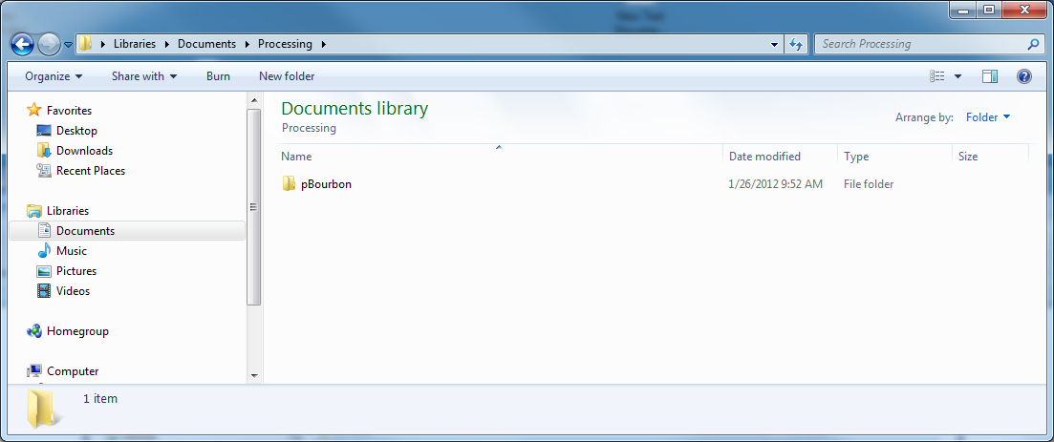

# Loading and Running Arduino program

Double click Aruino icon

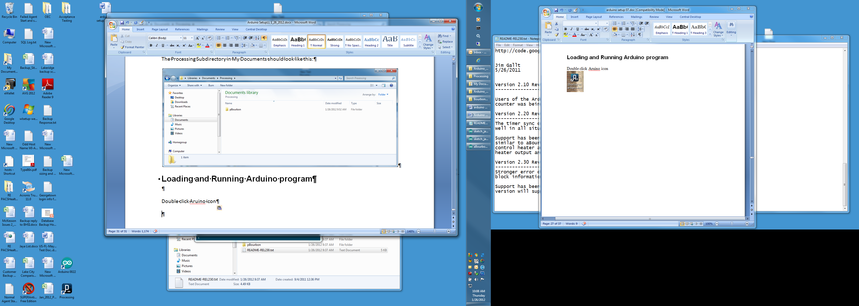

Click File> Sketchbook> aBourbon

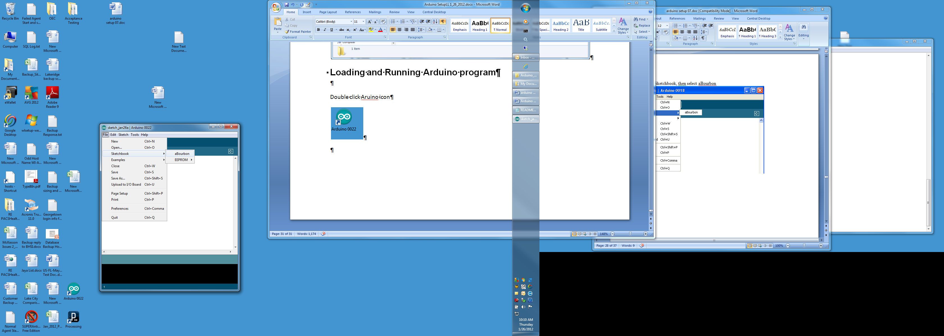

This is what you should see:

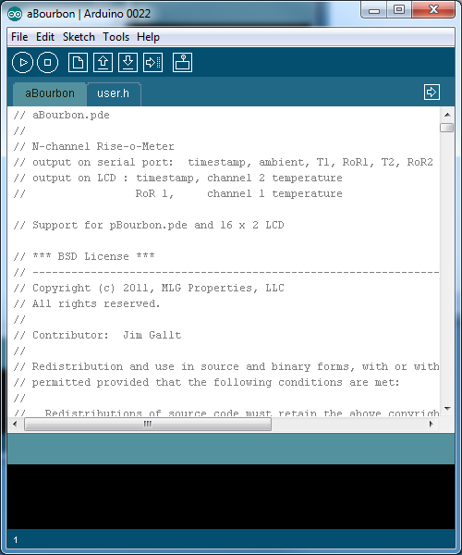

Make sure the correct COM Port and Arduino board are still selected.

Select Verify.

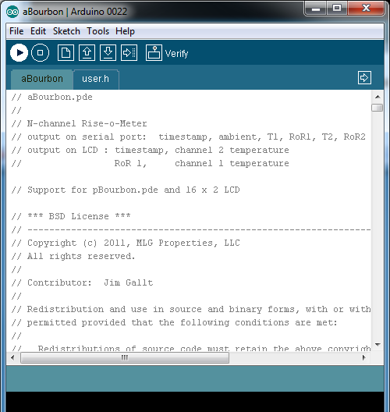

The program should compile without errors.

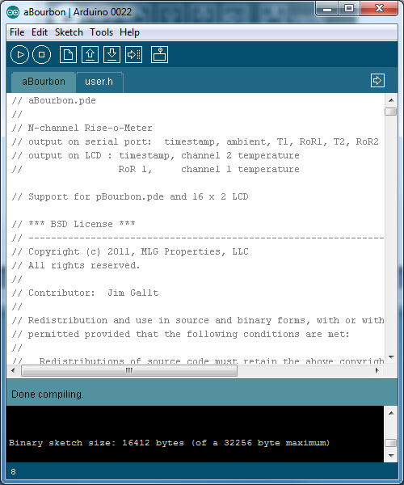

Select Upload.

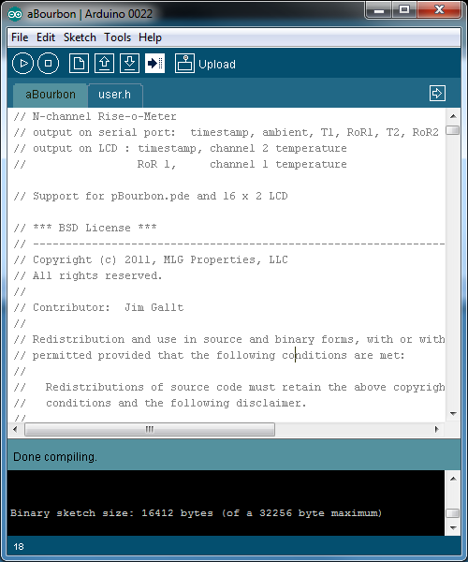

When done uploading you should see this:

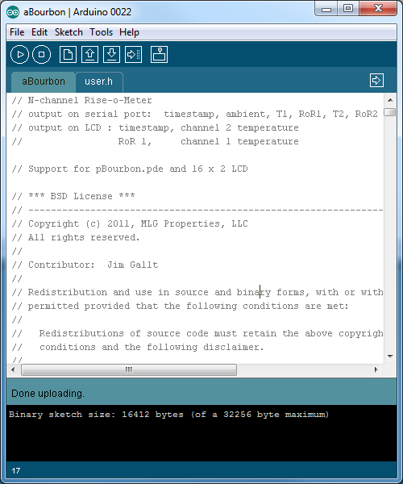

Arduino program is uploaded, and running now.

You do not have to upload again, unless there is a change. The software is saved in non volatile memory, so it will stay after a power cycle. You just need to power up the Arduino, and it will start running the program again.

# Fixing the COM port in Processing Program

Go to “My Documents\Processing\pBourbon”. It should look like this:

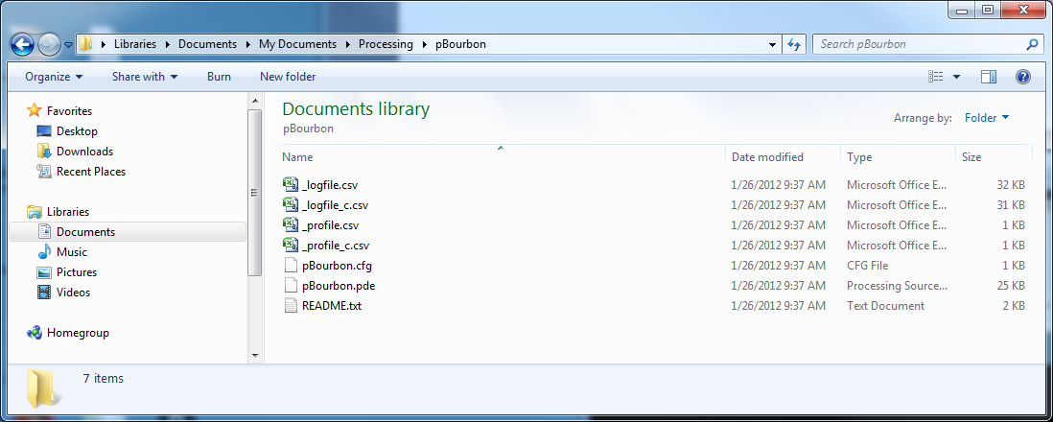

Edit the pBourbon.cfg file. You can use Wordpad or Notepad. Double click the file. You’ll see this window:

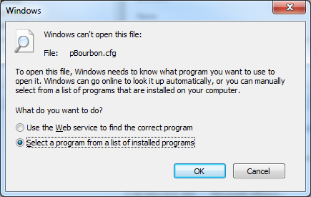

Click the radio button next to Select a program… and click OK.

Select Notepad or Wordpad and click OK.

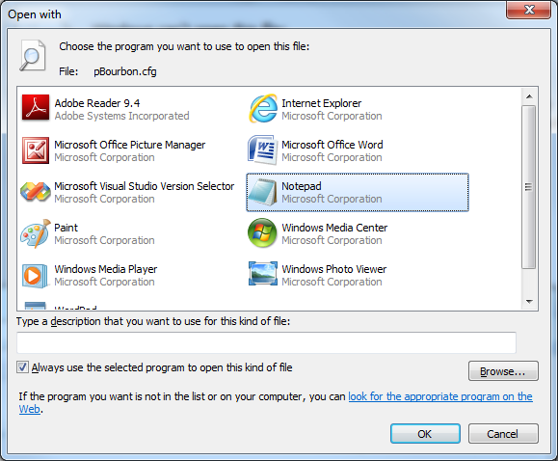

The default file looks like this:

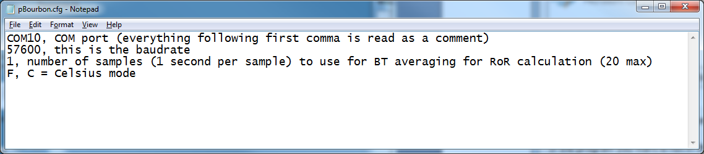

Edit the COM Port to whatever port is used by Arduino.

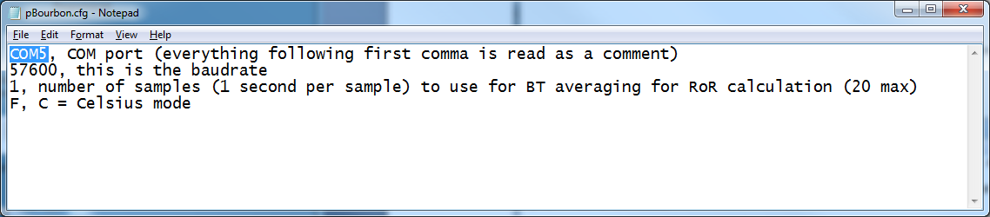

Save and close the file.

# Running Processing program

Double click on the Processing icon

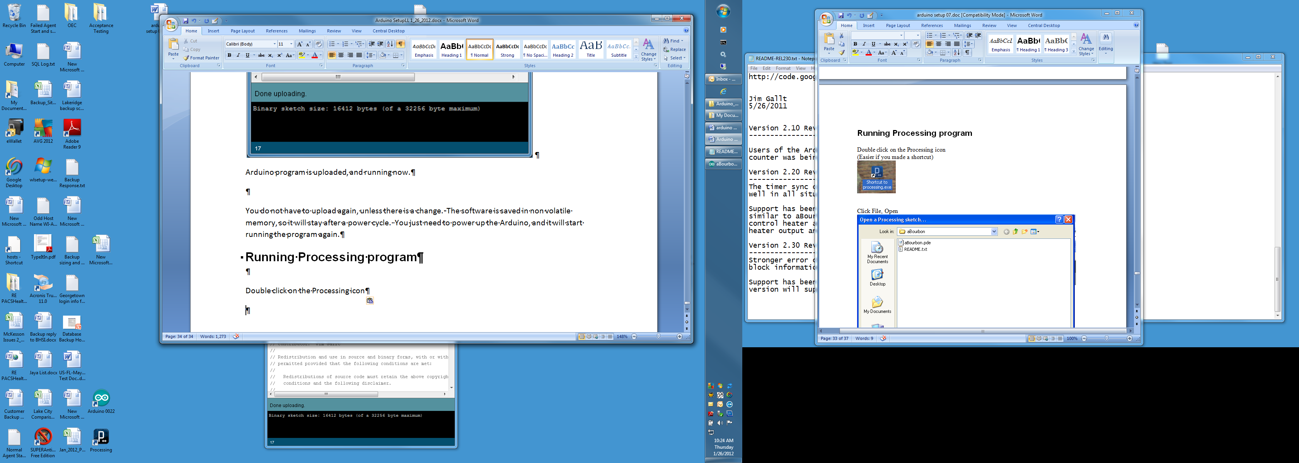

Click File> Sketchbook> pBourbon.

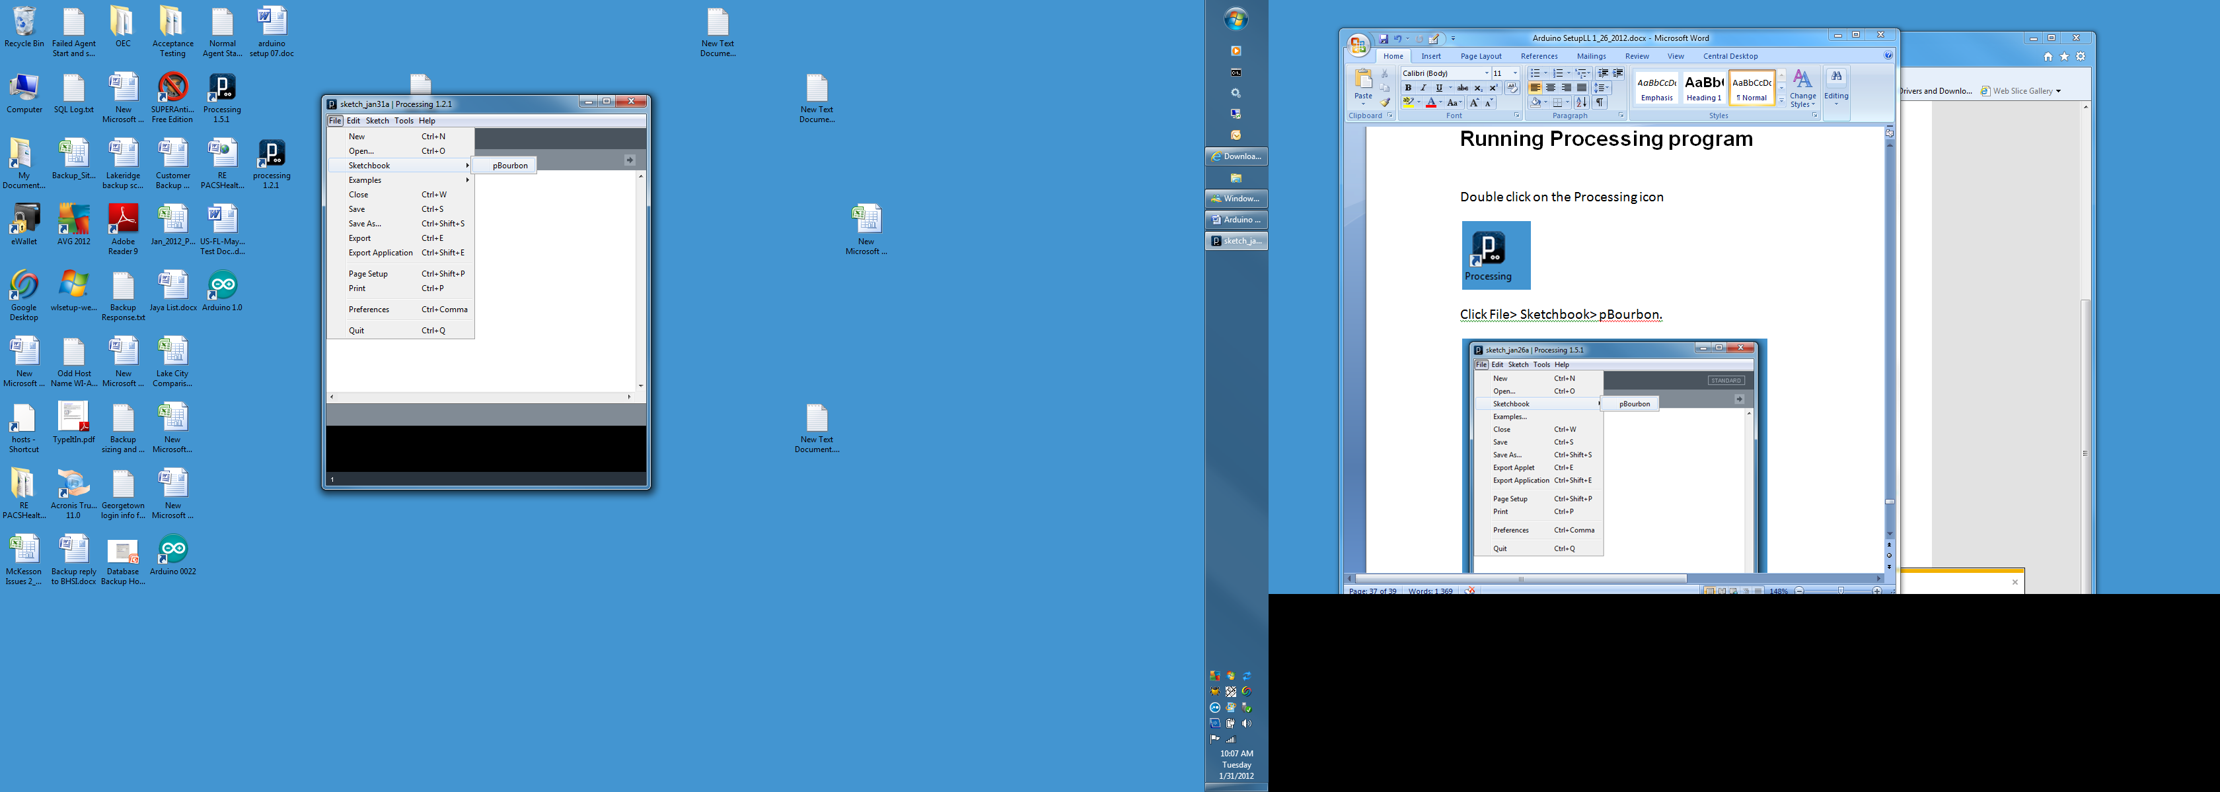

You should see something like this:

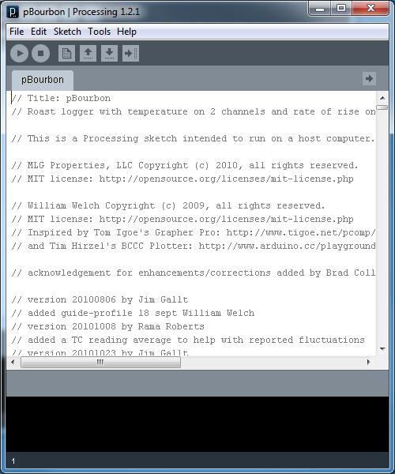

Select Run.

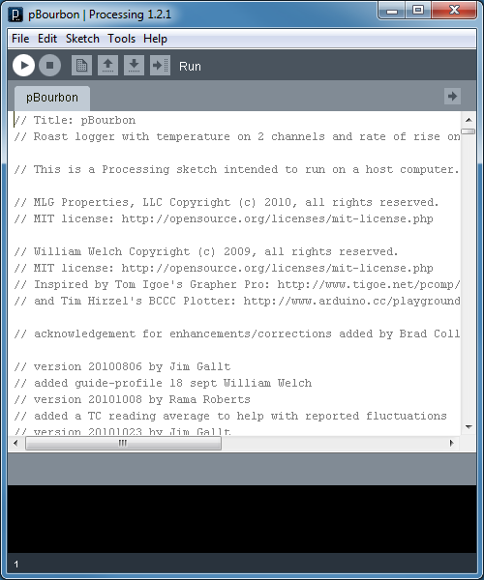

The original pBourbon window (which may be hidden beneath the window shown below) should look something like this when expanded:

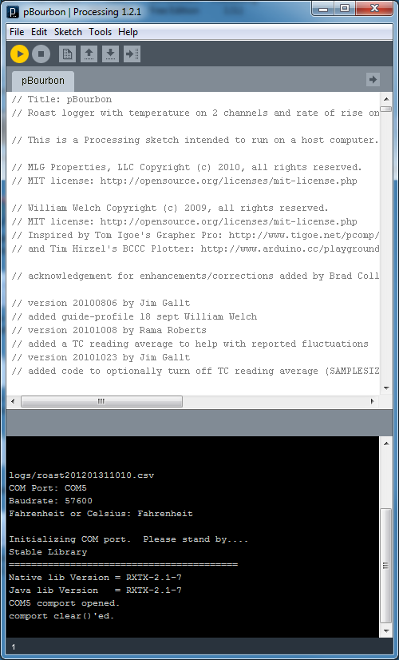

A new window should open up and you should see this:

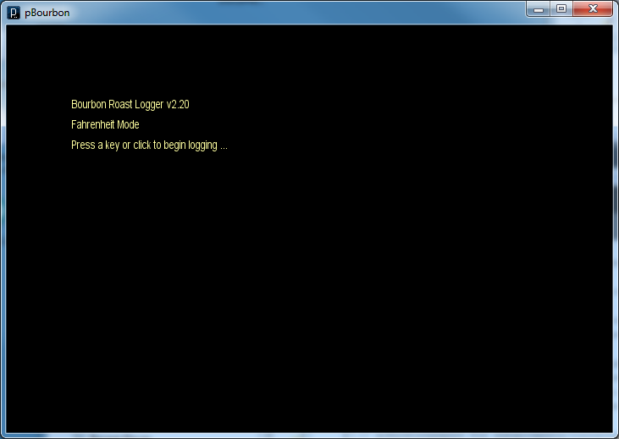

After clicking in the window you should see this:

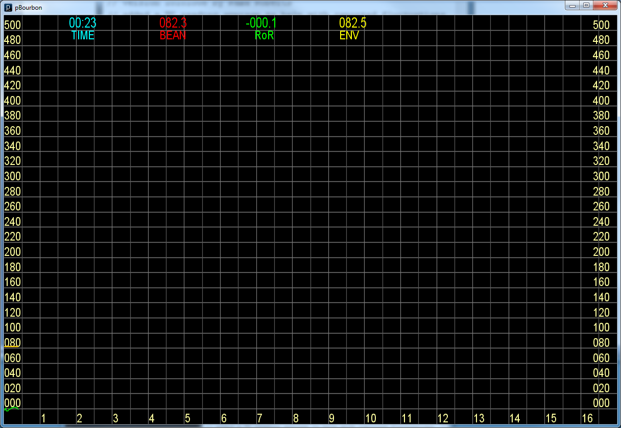

Log files are located in this subdirectory:

\My Documents\Processing\pBourbon\logs